University of Technology, Sydney

Faculty of Engineering and Information Technology

**Programming of an Inertial Measurement Unit**

**By**

**Jian Carlo Calaunan**

Student Number: 11244252

Project Number: S14-142

Major: Electrical Engineering

Supervisor: Dr Steven Su

A 12 Credit Point Project submitted in partial fulfilment of the

requirement for the Degree of Bachelor of Engineering

19 June 2015

Statement of Originality

The work contained in this report, other than that specifically attributed to another source, is that of the author(s) and has not been previously submitted for assessment. I understand that, should this declaration be found to be false, disciplinary action could be taken and penalties imposed in accordance with University policy and rules.

Jian Carlo Calaunan

17/06/2015

Abstract

Inertial Measurement Unit (IMU)

Jian Carlo Calaunan

Autumn 2015

The Capstone project centers on a device comprised of both accelerometers and gyroscopes to reproduce the human vestibular system, which determines balance and spatial orientation. This Inertial Measurement Unit (IMU) is a fundamental component in this project, as a Graphical user Interface (GUI) will be programmed to utilize the device for its viability in Gait analysis using only its accelerometer readings.

The development of this interface is to be conducted on LabVIEW where a visual programming approach is required to build the Virtual Instrument (VI). This GUI will interface with the IMU in real-time to provide visual quantitative readings from the device, such that a Gait Analysis can be performed utilizing those readings. There will be no physical interface between the program and the device, as the transmission of data between the two will be wirelessly communicated via Bluetooth.

The instrument will be program as a typical pattern recognition system and evaluate gait patterns by using a K Means clustering algorithm.

The success of the project is beneficial to the community as it can be applied to the medical field where it can be utilized in providing feedback for artificial attachments known as a prosthesis and many other systems. This medical application is known as Gait Analysis, it typically uses the IMU’s to assist people with abnormal movement and/or posture problems and fix these issues by providing remedial treatments.

Acknowledgement

I would like to acknowledge Steven Su for providing me with this great learning experience and opportunity for this Capstone project as I have a particular personal interest in these sort of medical applications. I appreciate his guidance and suggestions in helping complete this project.

My acknowledgements also extend to the UTS library as the textbooks and educational access to Literature Reviews and Journals have provided me with a sufficient amount of knowledge to conduct this project.

Table of Contents

2 List of Figures 7

3 List of Tables 8

4 List of Equations 8

5 Introduction 9

6 Literature Review 10

6.1 Gait Analysis 10

6.1.1 Technology used in Gait Analysis 10

6.1.2 Applications of Gait Analysis 12

6.2 Pattern Recognition 16

6.2.1 Classification 16

6.2.2 Estimation 16

6.2.3 Uncertainty 16

6.3 Models 17

6.3.1 Fixed Models 17

6.3.2 Parametric Models 17

6.3.3 Nonparametric / Data-driven Models 17

6.3.4 Pre-processing Models 17

6.4 Learning Algorithm 18

6.4.1 Nonparametric 18

7 Scope of Works 23

7.1 Problem Statement 23

7.2 Deliverable 23

8 Equipment 24

8.1 Hardware 24

8.1.1 Sensor board 24

8.1.2 Controller board 25

8.1.3 Bluetooth 2.0 mini USB Adapter 26

8.2 Software 27

8.2.1 Terminal Program 27

8.2.2 NI LabVIEW (National Instruments Laboratory Virtual Instrument Engineering Workbench) 28

8.2.3 NI MAX (National Instruments Measurement & Automation Explorer) 29

9 Cost 30

10 Experimental Setup 31

10.1 Equipment Setup 31

10.1.1 Terminal Program Initialize 32

10.1.2 NI MAX Initialize 33

10.1.3 Auto run Mode 34

10.1.4 Summary 35

11 Design 36

11.1 IMU Setup Diagram 36

11.1.1 Pattern Recognition System 37

11.2 Do a decision logic program flow 44

12 Findings 45

12.1 Problem Definition 45

12.2 Data Collection 45

12.3 Data Preparation 47

12.4 Data Preprocessing 49

12.5 Algorithm Implementation 49

12.6 Algorithm Training Parameters 50

12.7 Train and Testing of Model 50

12.8 Model Evaluation 51

13 Conclusion 52

13.1 Future Works 52

14 References 53

15 Appendices 56

15.1 Appendix A – LabVIEW Virtual Instrument 57

15.2 Appendix B – 6 Degrees Of Freedom v4 Datasheet 64

15.3 Appendix C – Three Axis Low-g Micro machined Accelerometer (1.5 – 6g) Datasheet 65

15.4 Appendix D – Machine Learning Toolkit User Manual 66

# List of Figures

Figure 1. MLP (Multilayered Perceptron) Model Source: (http://www.mdpi.com/sensors/sensors-13-15613/article_deploy/html/images/sensors-13-15613f7-1024.png) 19

Figure 2. K Means Training Flow Chart (Kennedy 1997) 22

Figure 3. IMU 6DOF v4 Sensor Board 24

Figure 4. IMU 6DOF v4 Sensor Board Top View 25

Figure 5. IMU 6DOF v4 Controller Board 25

Figure 6. IMU 6DOF v4 Controller Board Back View showing Bluetooth Module 26

Figure 7. Bluetooth 2.0 mini USB Adapter 26

Figure 8. Putty Interface 27

Figure 9. NI LabVIEW 2013 28

Figure 10. NI MAX (National Instruments Measurement & Automation Explorer) Program 29

Figure 11. Add Device via Control Panel 31

Figure 12. Device Manager Serial Port Settings 31

Figure 13. PuTTy Interface - IMU Configuration Menu 32

Figure 14. IMU Idle State (White LED) 32

Figure 15. NI MAX Initialization 33

Figure 16. NI MAX VISA Test Panel 34

Figure 17. IMU Autorun Mode (Green LED) 34

Figure 18. IMU Autorun Mode (Red LED) 34

Figure 19. IMU Autorun Mode (Blue LED) 34

Figure 20. IMU Connection Diagram 36

Figure 21. Pattern Recognition System Development Process 37

Figure 22. LabVIEW Logic Flow Diagram 44

Figure 23. LabVIEW Continuous Serial Read and Write Example 45

Figure 24. LabVIEW VI Early Prototype before Producer/Consumer Method 46

Figure 25. LabVIEW Producer/Consumer Data Pattern Template 48

Figure 26. LabVIEW Complete Program Overview 57

Figure 27. LabVIEW Data Collection Phase False Case 58

Figure 28. LabVIEW Data Collection Phase True Case 58

Figure 29. Data Preparation Phase 59

Figure 30. Data Preprocessing Phase 59

Figure 31. Algorithm Implementation, Training, Testing & Evaluation (1/3) – Stationary 60

Figure 32. Algorithm Implementation, Training, Testing & Evaluation (2/3) – Walking 60

Figure 33. Algorithm Implementation, Training, Testing & Evaluation (3/3) – Running 61

Figure 34. LabVIEW VI Front Panel 61

Figure 35. Read From CSV File Sub VI 62

Figure 36. Filter File Non-zero Data Sub VI 62

Figure 37. String Manipulation Prototype 63

# List of Tables

Table 1. Estimated Costs for Provisional Equipment 30

Table 2. Ongoing expenses 30

Table 3.Cost of Components Essential to Project 30

# List of Equations

Equation 1. MSE (Mean-squared Error) Function 19

Equation 2. RBF (Radial Basis Function) 20

Equation 3. Euclidean Measure 21

Equation 4. K Means Distance Equation 21

# Introduction

The problem is defined and the contents of each Chapter discussed briefly.

The motivation behind undertaking this type of project is the development of a medical analysis instrument programmed on a software known as LabVIEW. The program will be used to conduct the viability of Gait analysis using the Inertial Measurement Unit’s (IMU) accelerometer sensors.

The

# Literature Review

## Gait Analysis

Gait analysis is the study of human movement, whereby the examination of specific bodily reactions for particular repetitive movements results in the capability of quantifying the human body’s actions, which can be used for other applications.

The analysis of gait begins with deciding the type of movement to be performed by the body, then the analysis of the body is sectioned based upon which body parts perform repetitive movements for instance, the gait analysis for walking would consider two main areas separately, they are the movements of the arms and legs. The repetitive movement being performed is known as a gait pattern and is divided into two distinct phases, which are the Stance and Swing phase.

Gait analysis was primarily performed in laboratories that were specifically designed to analyse the body’s movement through the use of video camera systems in combination with force platforms, these platforms determined the ground reaction forces that the body produced. However, with the improvement of technology, it has allowed portable sensors that can be securely attached to the human body to be used in gait analysis.

### Technology used in Gait Analysis

With the improvement in technology in the recent years, the equipment to perform gait analysis has become cheaper, more compact, accurate and its versatility, such as how the data is collected and its ability to interact with other technology.

#### Sensors

##### Inertial Measurement Unit (IMU)

This device was primarily comprised of two fundamental sensors, an Accelerometer and a Gyroscope. The IMU can be integrated with other type of compact sensors that increases the performance such as it precision and stability, as well as extending the IMU’s ability and applications. The sensors typically manufactured in combination with the sensors mentioned above, are the Magnetometer and the Pressure sensor.

###### Accelerometer

This sensor is attached on the leg to allow the measurement of the linear acceleration of the leg during gait.

Typically three accelerometers, known as multi-axis models are required, in order to measure the acceleration with respect to its reference axis and provide a 3D-model representation i.e. x, y and z-axis.

Types of Accelerometers

There are a number of various types of accelerometers that are have been developed for different purposes, only a few are applicable for gait analysis and have been narrowed down to piezoelectric, piezoresistive, and capacitive accelerometers (Tao et al. 2012). Of the three mentioned the two ideal sensor types are the piezoresistive and capacitive, as they provide greater stability and dual acceleration components i.e. magnitude and direction (Tao et al. 2012).

###### Gyroscope

A sensor that is fundamental in aeronautics as it allows the detection of pitch i.e. to rotate up/down, roll i.e. rotate left/right and yaw i.e. rotate counter-clockwise/clockwise. The application of this sensor in gait analysis allows the measurement of the angular velocity and the angle displacement of leg during gait.

Similar to the accelerometer sensor, this sensor provides the rotational data during gait and typically requires three sensors in measuring different axis’ i.e. roll, pitch and yaw. This sensor is particularly useful in assessing the balance and posture of an individual.

Types of Gyroscopes

Gyroscopes based on other operating principles also exist, such as the electronic, microchip-packaged MEMS gyroscope devices typically found in consumer electronic devices, solid-state ring lasers, fibre-optic gyroscopes, and the extremely sensitive quantum gyroscope.

###### Magnetometer

The basis of this sensor operates on the principle of changing magnetic flux, in other words if a magnetic field is present then the tilt angle relative to the reference point will change in the device. This is of particular use in gait analysis, as it detects when a change in orientation occurs.

Types of Magnetometer

There are two general types of magnetometers and they are either a scalar or vector type. The scalar type provides simply the magnitude of the magnetic field whilst the vector provides both magnitude and direction. The magnetoresistive sensor is ideal for gait analysis and falls under the vector type category.

###### Force Sensor

The strain gauge sensors otherwise known as load cells, are typically utilized for force sensors used in gait patterning as they are compact and relatively inexpensive to reproduce. It operates based upon electrical resistance due to twisting displacement from its original place. The sensor is typically used to detect the ground reaction forces exerted during gait and provides a 3D vector representation of the magnitude exerted.

#### Electromyography (EMG)

This technique measures the voltage potentials of impulses emitted during muscle contractions using either surface or wire electrodes. The electrical activity emitted by the skeletal muscles is recorded and evaluated to determine the nerve cell health of the muscles. Generally, surface electrodes are utilized for gait analysis, as they are less invasive and more widespread than its counterpart is.

### Applications of Gait Analysis

With improvements occurring in the biomedical engineering field, gait analysis has become widespread particularly with the use of several sensor combinations to analyze gait patterns. The applications have become widespread influencing various aspects of life to order to assist and improve the body’s mobility and functionality. The two main areas where gait analysis has been applied to are the sporting community and the medical field.

#### Athletic Community

Its application in the athletic community is to assist in improving athletic performance, this is achieved by recognizing the muscular faults in the gait patterns that are inefficient could be improved, it is also includes injury prevention by correcting improper form during the movement.  
Recent technology has provided the availability of portable, wireless and remote coaching of individuals whether they be competitive athletes, sporting enthusiasts or hobbyist to ordinary individuals. Devices such as ‘Beast’ and ‘GymWatch’ are comprised of sensors mentioned in section 6.1.1 that interface via Wi-Fi or typically through Bluetooth to store and display the data onto an application on a smart device such as a tablet or smartphone. The application allows for real-time analysis that can be viewed remotely by a professional for immediate feedback, the application may also provide suggestions on improvement based upon baseline measurements built into the program itself.

#### Medical Field

The medical field application of gait analysis allows for the improvement primarily in diagnostic checks of the body. The ambulatory method is the adaptation of gait for walking, this particular method is important to determine irregularities in their gait pattern and is frequently applied in the industry.

Due to the medical field having a wide variety of professions, the careers that benefit from accurate diagnosis in terms of human movement are Physicians. These individuals are generalized as specialist in restoring and maintaining human health. This profession allows for specialization into specific treatment areas such as surgeons, cardiologist, dermatologist, endocrinologist, gastroenterologist, etc. The specialist field of interest is known as orthopedics, as this field is the study the human musculoskeletal system, which are the essential parts of the body that allow movement i.e. bones, joints, ligaments, tendons, muscles and nerves. The Orthopedic physicians utilize their specialized knowledge to diagnose and provide treatment to irregularities occurring in the musculoskeletal system. There are numerous applications of gait analysis practiced by orthopedic physicians that have been tested and verified in their treatments. Joint replacement otherwise known as Arthroplasty, was used in combination with gait analysis for monitoring the progress before and after treatment. This application was successful as it provided data that showed significant improvements overtime (Atallah et al. 2011, Aminian & Najafi 2004) in the patient’s health. These types of treatments use the ambulatory method as the baseline in order to determine if the patient’s progress is improving.

Gait analysis has also been utilized to detect diseases, specifically the ones that affect the motor functions of the body such as Parkinson’s, which causes motor dysfunctions within the body. Recent studies on the use of gait analysis as an alternative measure of the severity of Parkinson’s disease have been increasing. *Salarian et al.* (Salarian et al. 2004) performed gait measurement in patients with Parkinson’s disease using a developed wearable sensor device and concluded that stride length is highly correlated with the severity of the disease. Similarly in section 6.1.2.1 to how sensors were tailored for athletic improvement, the manufacturing of sensors for patients diagnosed with this disease have been developed.

The sensors tailored for Parkinson’s patients are also applicable to stroke patients, as they have impaired mobility and as a result are unable to move independently due to the incident. Ambulatory gait analysis is applied in the automatic identification of temporal gait parameters of post-stroke individuals to provide an assessment of the functional utilization of the affected lower extremity as part of the behavior enhancing feedback (Salarian et al. 2004, Saremi et al. 2006).

#### Security

The application of gait analysis extends to personal security based upon the personal characteristics of an individual, this is known as biometric security. This type of security provides a unique signature that cannot be reproduced by someone else. In terms of gait pattern, when a gait comparison between two individuals is closely observed and analyzed, the results will show there are slightly variations in the kinematic and kinetic patterns between the two individuals. This is due to several factors such as age, weight, height, etc. which affect the musculoskeletal system of the individual. To achieve a detailed gait analysis, a complex system comprised of multiple sensors would be required however due to the technological improvements as of late, a precision accelerometer sensor would be adequate enough to record a gait pattern (Ma ̈ntyja ̈rvi et al. 2005, Gafurov, Helkala & Søndrol 2006).

The biometric gait security system uses a recognition algorithm to validate whether the attempted gait pattern is the same, otherwise if there are major discrepancies to the gait pattern stored in the database the authentication would obviously fail.

There are typically two implementations of gait pattern recognition, either vision or sensor-based. The vision-based recognition operates based on two classes, either model based or model free. Both models operate on statistical measurements, they only differ in what the measurements are referenced with respect to i.e. model based uses the models discernable dimensions, such as height and width whereas the latter uses the outline of the models body.

The operation of sensor-based recognition works primarily off sensory data from the multi-axis accelerometer (Ma ̈ntyja ̈rvi et al. 2005, Gafurov, Snekkenes & Buvarp 2006). It can also be combined with a multi-axis gyroscope to provide a more distinct sample than with an accelerometer alone, allowing the balance and posture of the individual to be taken into account.

## Pattern Recognition

The fundamental process of performing pattern recognition involves processing the input data and assigning a label to the data based upon its characteristics, which is determined by the pattern recognition system.

The processed label is just one of the many labels that help identify the input data, as it defines one of the many unique characteristics of the processed data. The label is utilized for comparisons of a separate data set to determine whether the new data set matches the processed data set.

The two common categories that the pattern recognition system defines a label are either classification or estimation, where the output label is dependent upon the vector input to the system.

### Classification

This category is based upon a set of observation parameters that define a finite set of labels, with no sequential order, to the observed input data. The parameters are set prior to the analysis of a sample data set and typically have predefined initial classes otherwise known as a group of labels that have similar or identical characteristics.

### Estimation

In contrast to the classification pattern recognition, this category is more quantitative as it has an infinite set of labels to assign. The estimation category is related to organizing numerical input data, into either exact values or if it falls within a range of values based upon the defined mapping.

### Uncertainty

Classification errors typically occur when the input data being processed have similarities with two or more separate classes; the system typically assigns the label to the highest probable class. The classification category is dependent upon whether the label matches or not, whereas estimation is simplistic in its approach of assigning the labels to its appropriate or closest matching classes by comparing sequentially throughout all infinite classes until the best match or its closest approximate is found.

## Models

The internals of a pattern recognition system can consist of one or a combination of models for classifying the input data for analytical comparisons, the standardized models are listed below.

### Fixed Models

This model is simply comprised of closed-form equation/s that classify the outputs based upon the mathematical calculation. Prior knowledge is required in developing this particular model in order to formulate the correct mathematical equation.

This model is simplistic however does not cater to varying parameters as the calculation is based upon a known constant for that specific context, the next model addresses this issue.

### Parametric Models

Data-driven models are similar to fixed models in the way they are structured; the key difference is that the equation takes several parameters to produce its output, thus a parametric model. It is far more flexible than the former model as it creates mappings dependent upon these parameters. These mappings once defined, are internally compared against each other in order to select the most viable mapping closest to the desired output.

### Nonparametric / Data-driven Models

The model centers around handles large volumes of unknown data typically read from data acquisition systems. The model requires an analyzed data set to compare the new incoming data with the predefined data set.

### Pre-processing Models

This particular model is used for complex situations where classifying the input data to the output labels is not possible when the quantity of data is of a larger magnitude than what a nonparametric model can process in an ideal time frame. Though the nonparametric model would be able to complete the task, it would take a sufficient amount of time and data to complete the pattern recognition.

Pre-processing takes into account several key factors to look out for; as a result, it decreases the period for each calculation to be completed.

Simply put this model takes a large magnitude of data inputs and screens it accordingly to the internal parameters, the outputs of this model is filtered data that is routed typically into a non-parametric model for labelling however it can also be applied to parametric models.

## Learning Algorithm

The main algorithms of concern are the non-parametric models present in the Machine Learning Toolkit (MLT), as the context of this project will require the manipulation of continuous data being input into the system via the IMU.

### Nonparametric

The following algorithms that fall under this category, will group data points based upon the training instructions and the algorithms methodology.

The nonparametric algorithms fall under two subcategories either unsupervised or supervised learning.

A supervised learning algorithm alters the parameters used to pattern the input data based upon the trained data. The unsupervised learning algorithm clusters the data with no specific order or pattern, the output data is essentially unlabeled.

#### Multilayered Perceptron (MLP)/Backpropagation (BP)

A form of neural network whose original purpose was to model neurological practices, the MLP achieves this objective by combining its architecture with the BP algorithm. This allows it to form nonlinear relationships between the incoming input data and the output labels formed by the algorithm.

In terms of just nonparametric modelling, MLP makes use of several tiers typically consisting of three layers as seen in Figure 1 but for patterns of greater complexity additional tiers, known as hidden layers are required. For an n number of inputs to the MLP’s first tier, the input layer will consist of an n number of nodes that represent the weight of that input. The next tier otherwise known as the hidden layer, contains nodes where individually the values are the weighted sums of the input nodes due to a sigmoidal function (Kennedy 1997). This node summation process continues until the output layer where the label is the weighted sums of the inputs. 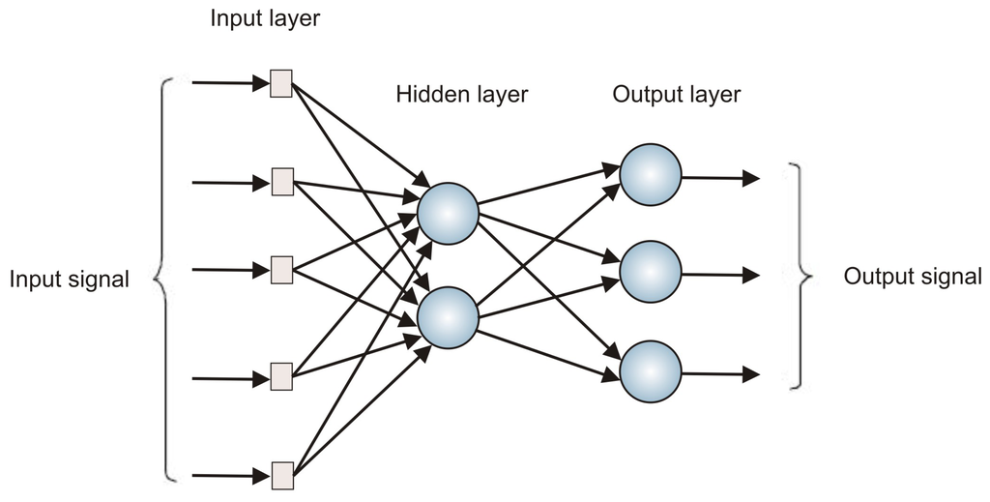

Figure . MLP (Multilayered Perceptron) Model Source: (http://www.mdpi.com/sensors/sensors-13-15613/article_deploy/html/images/sensors-13-15613f7-1024.png)

The MLP output is used by the BP algorithm to obtain the desired results; this is achieved over several iterations of tuning the weights of the MLP via a mean-squared error (MSE) function Equation 1 (Kennedy 1997).

$$E=\sum_{i=1}^{N_{train}}{\left\{\frac{1}{2}\sum_{j=1}^{J}{{(d_{ij}-y_{ij})}^{2}}\right\}}$$

Equation . MSE (Mean-squared Error) Function

where *i* and *j* are the indexes of *Ntrain* patterns of the training set and each output variable respectively. The trained output dij of *j* index output from *i* index pattern and *yij* is the calculated output from the model.

#### Radial Basis Functions (RBF)

Similar to MLP in mapping inputs and outputs based upon weighted sums, the function however uses radial Gaussians Equation 2 instead of the MSE function Equation 1 (Kennedy 1997).

$$y=\sum_{i=1}^{N}{w_{i}e^{\left(-\frac{1}{2σ_{i}^{2}h}\right){\left({X-Mean}_{i}\right)}^{T}\left(X-{Mean}_{i}\right)}}$$

Equation . RBF (Radial Basis Function)

where *y* is the output of the algorithm, *N* are the number of radial Gaussian functions, *X* is the vector input, *i* is the i-th radial Gaussian function, *Meani* is the location of the center, $σ_{i}$ is the spread, *h* being the overlap factor, *w0* is the bias and *wi* is the weighted sum of that specific radial Gaussian function (Kennedy 1997).

RBF is similarly trained as BP however, its processing time can be improved when combined with K Means Clustering, and the combination of the two minimizes the variation between the training patterns to the Gaussian centers. This optimization is achieved by tuning the weights of each Gaussian such that the MSE is minimized on each iteration.

#### K Nearest Neighbors (KNN)

KNN is simplistic in its operation in that it stores the input and output pairs of a training set in a database, the size of the stored database is highly dependent on the dimensionality of the training set. The database acts as a reference for new input patterns however despite the pre-processed training pattern the limiting factor of this algorithm is in the overall dimensionality of the training set, essentially the more patterns in the stored training set the longer the comparison process will take to examine through the training set.

KNN utilizes the Euclidean measure Equation 3 as a means of comparison between the patterns within the training to the input pattern; Equation 3 allows the input pattern to find its closest match in the training set, thus its nearest neighbor.

$$Dist\left(X,Y\right)=\sqrt{\sum_{i=1}^{D}{{(x_{i}-y_{i})}^{2}}}$$

Equation . Euclidean Measure

where the distance calculated is of *i* dimensions between the input pattern to the closest pattern within the training set.

#### K Means Clustering

K means is a widely utilized algorithm primarily due to its simplicity in assigning or organizing data into the nearest cluster. These clusters, otherwise known as classes are user dependent and thus influence the amount of data points per cluster.

These cluster centers are calculated based upon the mean distance of each individual data point assigned to it.

$$J(X,V)=\sum_{i=1}^{c}{ \sum_{x_{k}∈{ C}_{i}}{{\left\|x_{k}-v_{i}\right\| }^{2}}}$$

Equation . K Means Distance Equation

where Ci is the *i*th cluster, *x*k is an element of set *C*i, *v*i is the current cluster center of Ci and $\left\|x_{k}-v_{i}\right\|$ is the distance between these two points (Vathy-Fogarassy & Abonyi 2013).

Once it is centered the cluster is split in half and the data points previously assigned to the prior cluster become members of the new clusters, where the new clusters are evaluated using the same process as the above i.e. the cluster finds its center by calculating the mean distance of the surrounding data points. After the original cluster is split, the process will iterate until the number of clusters specified by the user is met. The data points are re assigned based upon their distance to the nearest cluster.



Figure . K Means Training Flow Chart (Kennedy 1997)

K Means Clustering typically creates a range of 2 to $\sqrt{K}$ clusters for data estimation purposes however for classification the number of clusters increases depending on the context (Kennedy 1997).

# Scope of Works

## Problem Statement

The purpose of this Capstone project is to design and implement a working program that will allow the IMU to work in combination with the program for gait analysis. The IMU data outputs to be processed by the program are the accelerometer readings in the X, Y and Z-axis.

## Deliverable

The projects primary objective is the development of this gait analysis program. From the thorough research performed analyzing several literature reviews, it has been deduced that the program will operate as a pattern recognition system in order to achieve the objective.

This pattern recognition system will quantify the typical human movement patterns, such as walking and running. The system will store these quantified biomechanics as individual test data sets in the system, where it will use these data sets for future classification comparisons.

# Equipment

## Hardware

As this Capstone Projects mainly revolves around programming, there is very little hardware required to achieve the 7.1 Deliverable of this document. The main hardware requirements are the IMU itself and a computer loaded with the LabVIEW software.

### Sensor board

In the context of this project, the IMU in its entirety allows the measurement and digital transmission of raw acceleration data to a measurement system. The IMU itself is comprised of two boards that each facilitate a specific operation, the sensor board provides the essential circuitry and regulators needed for the attached sensor to operate.

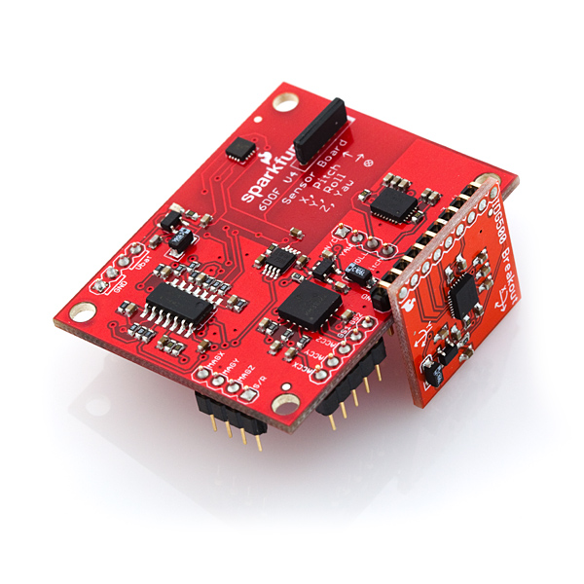

Figure . IMU 6DOF v4 Sensor Board

The sensor board has pins pre-soldered from the manufacturer, as seen in Figure 3 above; this is to allow connection with the controller board for added functionality.

#### Freescale MMMA7260Q three Axis Low-g Micro machined Accelerometer (1.5 – 6g)

The IMU is comprised of multiple modules; the most significant of them is the three axis accelerometers. For the simplicity and transparency of the project, only the accelerometers are to be utilized which is due to the acceleration changes occurring during the legs swing motion when movement occurs.

The reference directions of the X, Y and Z-axis are as depicted on Figure 4.

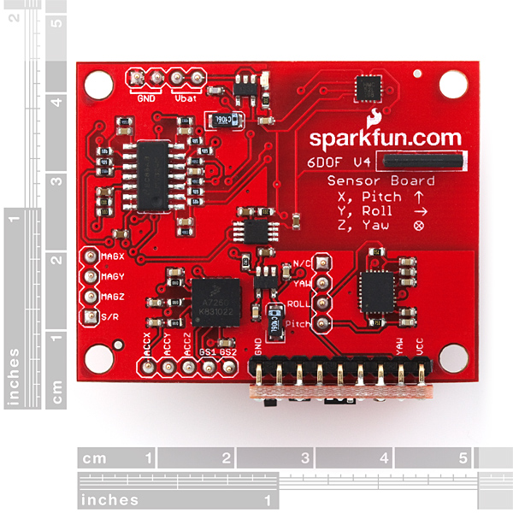

Figure . IMU 6DOF v4 Sensor Board Top View

### Controller board

The controller board provides the user with the control of the sensor through the boards LPC2138 ARM7 Processor, the board also provides power for both platforms. Once connection is established, the memory in the processor can be manipulated with the WinARM software, provided by SparkFun, to alter the code for private or commercial use.

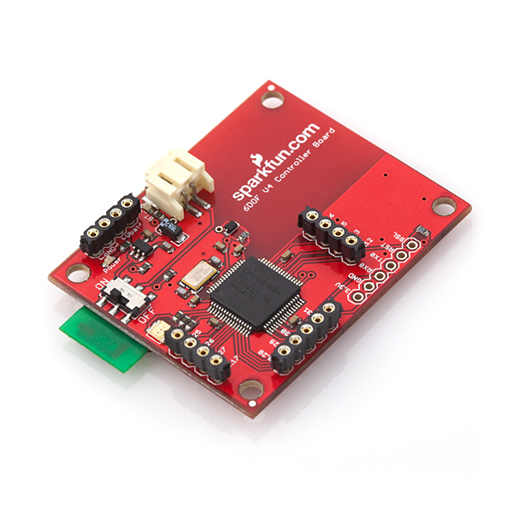

Figure . IMU 6DOF v4 Controller Board

On the underside of the board is where the built-in Bluetooth module is positioned, this module allows for wireless communication with any computer provided the appropriate adapter is present in pairing with the device.

#### Roving Networks Bluetooth Module

This module comes built-in to the IMU from the manufacturer; the additional module provides a wireless communication alternative method. The Bluetooth module is essential to this project as data samples from the IMU will be sent whilst on the move, due to the fact that it is to be attached to a moving ligament for gait analysis.

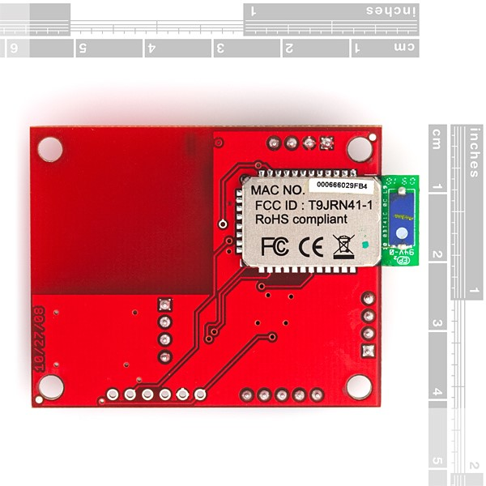

Figure . IMU 6DOF v4 Controller Board Back View showing Bluetooth Module

### Bluetooth 2.0 mini USB Adapter

A minimum of a class 1 Bluetooth v2.0 adapter is required for Bluetooth communication to function correctly as recommended by SparkFun for this particular Bluetooth module as seen on their website (refer to <http://www.sparkfun.com/products/9434>).

The limitation of the adapter is reportedly a maximum of 100m with only one possible active connection.

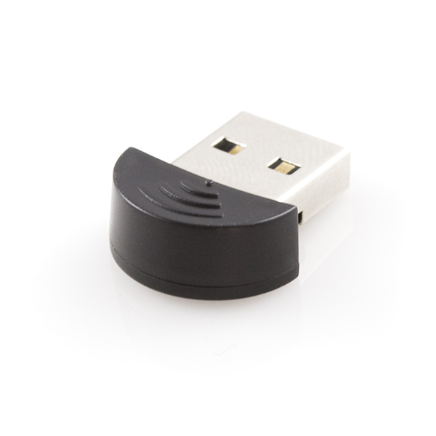

Figure . Bluetooth 2.0 mini USB Adapter

## Software

It is crucial for the computer to have the appropriate hardware requirements to run and have compatibility with the following software.

### Terminal Program

The IMU Bluetooth connection to the computer is made as a serial communications port is created, commonly seen in Device Manager as COM1, COM2, etc. The software required to communicate and access the data transmitted through this port is a terminal program.

Once a Bluetooth connection between the computer and the IMU is established in the computers Device Manager, a terminal program is initially required to communicate with the device to setup and ensure its operating correctly as specified by the IMU data sheet (refer to Appendix B – 6 Degrees Of Freedom v4 Datasheet).

#### PuTTy

Under the supervisors and another academics’ use of the IMU, this particular software is picked amongst the other notable emulator terminal programs available on the Internet, primarily for its portability and cost effectiveness.

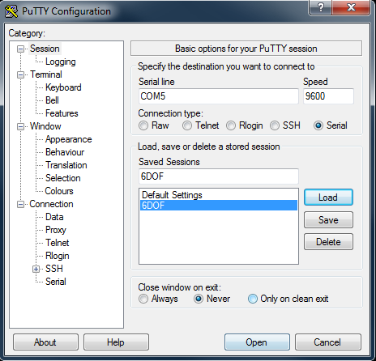

Figure . Putty Interface

### NI LabVIEW (National Instruments Laboratory Virtual Instrument Engineering Workbench)

Software designed by National Instruments that have designed it specifically towards engineers and scientists that spend time on any measurement or control system.

The software allows for the programming of new instrument programs known as Virtual Instruments, it’s also utilized for the improvement and/or adaptation of existing Virtual Instruments for private, commercial or educational purposes.

This is the primary software to be utilized throughout this project; the software will be programmed for data collection and manipulation to meet the objectives of this project, which is for gait analysis.

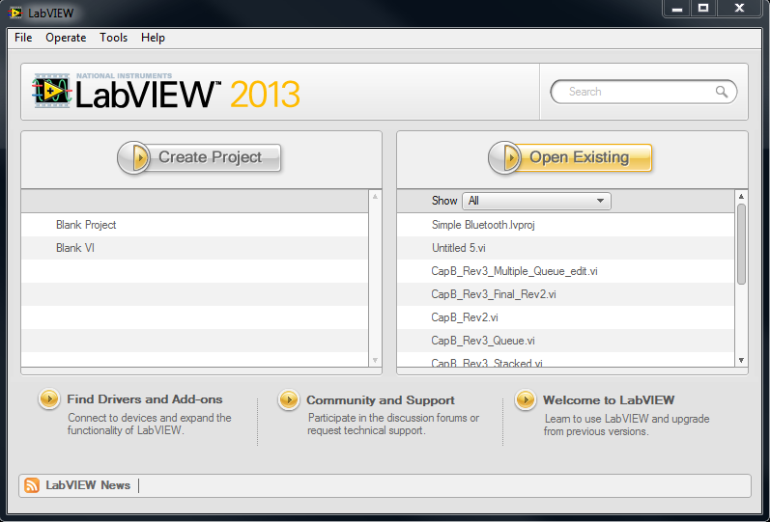

Figure . NI LabVIEW 2013

### NI MAX (National Instruments Measurement & Automation Explorer)

The explorer allows the configuration of all physical devices connected to LabVIEW or utilized by its Virtual Instruments. The devices capable of integrating with LabVIEW are specific to those provided by National Instruments that are:

|  |  |
| --- | --- |
| * CAN (Controller Area Network) * DAQ (Data Acquisition) * FieldPoint * GPIB (General Purpose Interface Bus) * IMAQ * Motion | * IVI (Interchangeable Virtual Instruments) * Modular Instruments * NI Switch Executive * VI (Virtual Instrument) Logger * VISA (Virtual Instrument Software Architecture) |

The software is quite sophisticated, it is not just limited to customizing the devices name and changing basic or advanced port settings, but also provides diagnostic checks, viewing of the devices attributes, write and reading privileges to connected devices.

This particular software comes included with the installation of LabVIEW and replaces the PuTTy software as it was utilized late in the project when troubleshooting of the virtual instrument was required due to errors occurring due to the device.



Figure . NI MAX (National Instruments Measurement & Automation Explorer) Program

# Cost

A minimal amount was invested on the projects overall costs, as the majority of the equipment was provided by the University of Technology, Sydney. The software and hardware requirements for the project are readily available in the Engineering Building computer laboratories.

The IMU was provided by the Capstone Supervisor, however should the unit be damaged, the cost of sourcing another identical unit would amount to the costs seen in Table 1 below.

|  |  |  |
| --- | --- | --- |
| **Product id** | **Component Name** | **Cost ($AUD)** |
| SEN – 08454 | SparkFun IMU 6DOF v4 with Bluetooth Capability (RN-41) | $ 449.95 |
| SEN – 08726 | SparkFun Standalone Sensor Board | $ 349.95 |
| SEN – 08727 | SparkFun Standalone Controller Board, built-in Bluetooth (RN – 41) | $ 99.95 |

Table . Estimated Costs for Provisional Equipment

The main expenses of the project were spent on its ongoing costs; in particular, its power source to ensure the device was always in working order.

|  |  |
| --- | --- |
| **Component Name** | **Cost (AUD)** |
| Energizer MAX AA Alkaline Battery (20 Pack) | $ 21.98 |

Table . Ongoing expenses

A single investment for the IMU platform and a Velcro hook strap was made for the continuation of the project. The platform was purchased prior to the start of this project and was adjusted for the IMUs’ placement.

An elastic Velcro hook loop strap was essential to the project, as it acts to harness the IMU and its platform to the subject’s leg, due to its elasticity it can cater to a wide range of test candidates with varying leg sizes.

|  |  |
| --- | --- |
| **Component Name** | **Cost (AUD)** |
| Bluetooth mini-USB adapter | $ 10.95 |
| Elastic Velcro hook loop strap | $ 5.00 |
| Platform | $ 7.00 |

Table .Cost of Components Essential to Project

# Experimental Setup

## Equipment Setup

For the computer to interact with the device the Bluetooth Adapter Module must be plugged into the computer, afterwards the device is switched on.   
The device will be detected by the computer as seen in Figure 11 and is added via the Devices and Printers in Control Panel.

If communications with the device are successful, a typical Bluetooth pairing request will be visible on the screen, entering the pairing code “*1234*” will complete the connection and a serial com port number will be assigned to the device as seen in Figure 12.

|  |  |
| --- | --- |
| Figure . Add Device via Control Panel | Figure . Device Manager Serial Port Settings |

The next step involves initializing the IMU either thru the terminal program PuTTy or NI MAX.

### Terminal Program Initialize

Using the terminal program and the COM port number provided in Figure 12, entering the appropriate input parameters as seen in Figure 8, should initialize the IMU device such that Figure 13 is seen. The initialization is a success if the tri-color LED is illuminated with all three colors red, blue and green lighting simultaneously as seen in Figure 14.

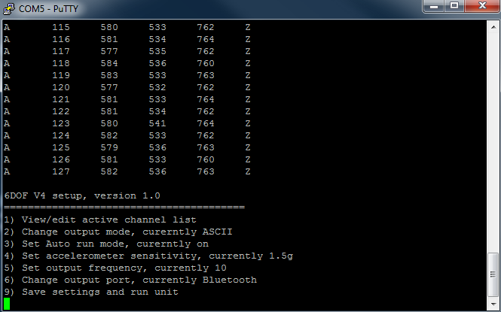

Figure . PuTTy Interface - IMU Configuration Menu

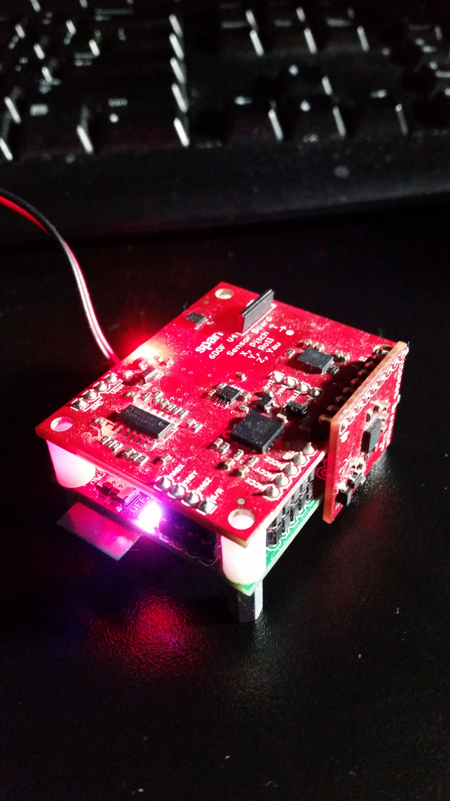

Figure . IMU Idle State (White LED)

The device is configured such that the only active channel lists being output by the device are the X, Y and Z-axis accelerometer readings.

To enable the sampling or recording of accelerometer readings, Auto run mode must be configured to be On and once setup like in Figure 13, sampling can begin by entering ‘*9*’.

Exiting the terminal program is required in order for LabVIEW to gain access to the device.

### NI MAX Initialize

Using the NI MAX program, the device can be found from the drop down selection in Devices and Interfaces as seen in Figure 15.

The IMU device can be renamed from its COM# name to a unique name for easier identification.

The initialization is much simpler than terminal and only requires opening the visa test panel as indicated in Figure 15.

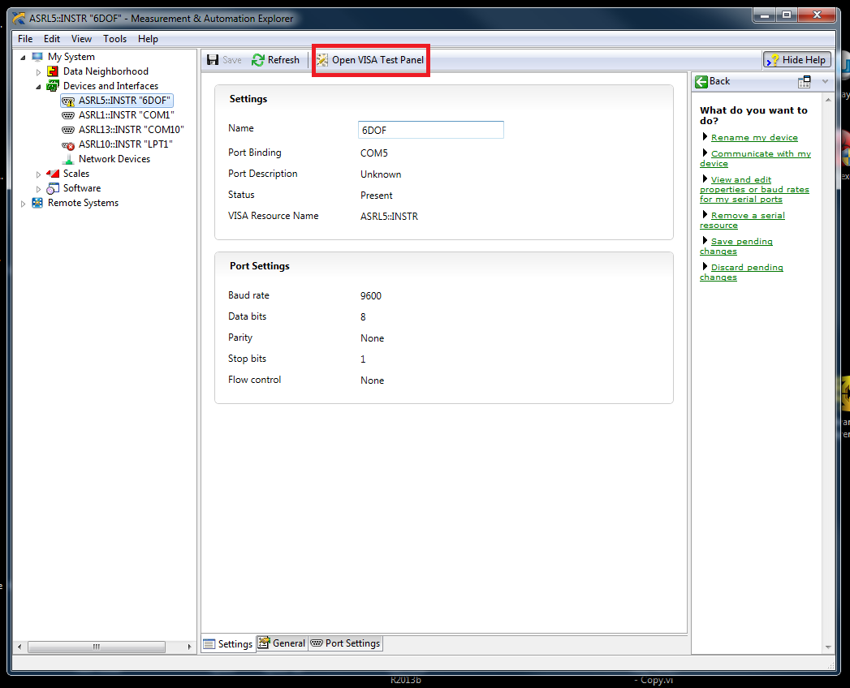

Figure . NI MAX Initialization

Upon clicking the Open VISA Test Panel and selecting the Input/Output tab as seen in Figure 16 will complete the initialization process via NI MAX. Closing the NI MAX program finishes the procedure.

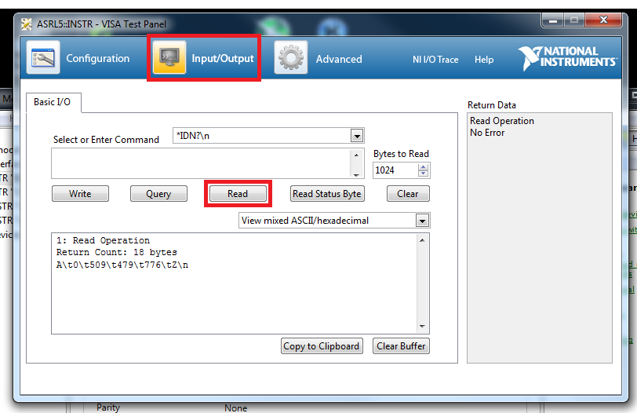

Figure . NI MAX VISA Test Panel

### Auto run Mode

When Auto run mode is enabled and sampling begins the lights on the device will begin to alternate from red, blue to green as seen in Figure 17, Figure 18 and Figure 19 below.

Entering ‘9’ in the terminal program or selecting ‘Read’ in the Open VISA Test Panel Input/Output tab as seen in Figure 16 will activate this mode on the device.

|  |  |  |
| --- | --- | --- |
| Figure . IMU Autorun Mode (Green LED) | Figure . IMU Autorun Mode (Red LED) | Figure . IMU Autorun Mode (Blue LED) |

### Summary

A summary of the startup procedure for the experiment is as follows:

1. Insert Bluetooth Adapter Module
2. Turn On IMU
3. Add Device via Control Panel
4. Enter Pairing Code 1234
   1. If successful, the tri-colour LED will be illuminating on the device (refer to figure), otherwise turn off and repeat Step 2.
5. Take note of COM port number
6. Initialize device thru:
   1. Terminal
   2. NI MAX
7. Close Terminal or NI MAX
8. Open LabVIEW VI

# Design

## IMU Setup Diagram

Figure . IMU Connection Diagram

The figure above shows the sequential data flow process required to read the raw outputs of the device. After the creation of the Virtual SPP, it becomes necessary to initialize the device to ensure communications with the device are functional and to wake up the device from sleep mode, should it become inactive after a length of time.

The initialization stage is important as the device can only have one active session open, therefore once the initialization is complete either NI MAX or the terminal program must be closed prior to running the LabVIEW VI.

### Pattern Recognition System

Figure . Pattern Recognition System Development Process

#### Problem Definition Stage

This stage involves evaluating the problem, in this case the pattern to be observed and data mined or modeled for recognition purposes. Once the evaluation is complete, the model/s that provide the best classifications are developed.

The device requires initialization to ensure the connection is established and communication between the computer and the device is working, this state will be indicated on the device by a white LED when achieved. Accessing the device thru either the terminal program or VI MAX will accomplish this process. No sign of a white LED light indicates the device is still in an IDLE state.

#### Data Collection

The collection stage is straightforward and determines how the data is to be collected from the IMU by the program. As the IMU datasheet specifies the outputs can be either binary or in ASCII format, here the latter is chosen as LabVIEW interprets ASCII as strings.

The string format output is of the form “*A 0 123 123 123 Z*” where the spaces in between are tab delimiters, A and Z denote the start and end of this particular sample respectively. The first integer denotes the sample count, then X, Y and Z-axis accelerometer readings follow after in that order evident in Figure 16.

After the IMU has been setup as seen in Figure 20. IMU Connection Diagram the collection of data can proceed in LabVIEW. The sampling of data is indicated by the short flash of the tri-color LED toggling between red, green and blue (refer to section 10.1.3).

Using the built in LabVIEW, instrument input/output function known as VISA (Virtual Instrument Software Architecture), can communication access and control of the IMU be possible.

The main LabVIEW functions of concern within the VISA category are:

* Configure Serial Port: Required for the visual display and detection of the IMU COM port.
* Open: Once the above is configured then a singular session can be opened with the IMU.
* Close: Closes the session, thus terminating LabVIEW’s access over the device.
* Write: Allows the user to send a string to the IMU, similar to the operation of the PuTTy except without a visual display.
* Read: VISA Read allows a string of *x* number of bytes to be read from the device.

The setup of the VI as seen in both Figure 27 and Figure 28 is comprised of three structures, the outer structure is the While loop used to keep the VI running until the user wishes to stop sampling. The nested structure inside the While loop is a Case Structure that runs a certain operation depending upon the conditions, in this case the Read On button. Inside this structure is another Case Structure, this structure makes use of both True and False Cases based upon the bytes read.

The Queue needs to be initialized, by using the Obtain Queue function and wiring in the expected data type to be queued i.e. Strings.

The Queues functions fall under the Queue Operations category, the main functions utilized within the context of this project are:

* Obtain Queue: Allows the creation of a Queue that handles a specific type of data otherwise known as an element.
* Enqueue Element: This adds the data of the element wired to the Queue.
* Dequeue Element: Typically wired to another section of the block diagram, this function removes the data from the queue.
* Release Queue: Similar operation to the Close Visa function, it ends the Queue.

Once the collection of one sample of data is read from the device, it is added to a Queue using the Enqueue Element function as seen in Figure 27, which allows the data is to be processed in a separate loop. The other case Figure 28 writes to the device to enable the Auto Run mode.

#### Data Preparation

The structure for this stage is the same as in the previous stage seen in Figure 29, this While loop structure will terminate as the user opts to stop sampling.

The Dequeue function extracts the raw data from the queue, this raw data is of a string format as mentioned previously; it is unusable and cannot be processed by numerical functions due to data incompatibility. The data format conversion to an integer or double is achieved using the Scan From String Function as seen in Figure 29 of Appendix A – LabVIEW Virtual Instrument, once converted the data is bundled into a cluster using the Bundle function and is wired into a separate queue that specifically holds the new data type. This queue requires a separate Obtain Queue function to be initialized by Cluster constant consisting of a string, integer, integer, integer and a string in that exact order.

The Cluster functions can be found in the Cluster, Class, & Variant category and are useful for handling multiple types of different data types. The only functions utilized are:

* Bundle: Groups together various data types to create the cluster data type
* Unbundle: Converts the cluster data type back into its individual elements.

The output error of the Dequeue and Scan from String function are merged together, wired to the Clear Error function, and fed back into their respective inputs.

#### Data Preprocessing

The preprocessing of the data occurs in the same structure of the algorithm however only occurs in the section indicated as seen in Figure 30, the structure is a While loop with the same terminating parameters as the previous two.

The Dequeue function takes the data out of the queue and unbundled, the only data types of concern are the integer values of the accelerometer readings. Three individual 1D arrays are built using these readings, each reading is associated with the sample count at which it was recorded, and the While loop iteration count is used as the sample count as exampled in the (section 12. Findings). The array outputs are bundled into a Cluster and individually all wired their respective hidden indicators i.e. indicators not visible on the VI Front Panel.

A user input on the VI Front Panel is created for the change in testing environment, using the average of the stationary Z reading from the trained pattern as a reference, the Z-axis reading prior to running the algorithm will need to be recorded to complete the preprocessing stage.

#### Algorithm Implementation

The algorithm will be running in a For loop nested inside a While loop structure containing all the preprocessed test data.

Each For loop will contain a separate analysis of each gait pattern i.e. walking, stationary and running. There will be three For loops running each pattern and are identical in operation. In the For loops will contain the VI’s from the MLT, the K-Mean and the 2D Visualization Plotter.

The local variable of the 1D array is unbundled and wired into the For loops such that they are Auto-Indexed, the process is repeated for the remaining two For loops.

#### Algorithm Training Parameters

Three numeric user inputs are created on the Front Panel of the VI but are not wired in the block diagram. These numeric inputs are used to represent the number of classes/clusters, one for each axis, these inputs are not wired, as they will be referenced from Local Variables that are located in the Structures category.

#### Train and Testing of Model

At this stage in the process, the algorithm is using the inputs that have been preprocessed and are wired into the K Means function where it will create the mappings of the trained models for each individual axis.

The testing and training of the model was immediately performed once for three distinct gait i.e. stationary/standing, walking and running patterns were collected and saved to a spreadsheet file. These files are read back into the system, the data must be is prepared then preprocessed before the next and final phase can begin. The data being collected from the spreadsheets are read using a Read CSV Sub VI (Figure 35) and are wired into another Sub VI (Figure 36. Filter File Non-zero Data Sub VI) where the data is filtered of outliers such as zeroes and only displays the relevant accelerometer values.

The number of samples from the spreadsheet is used as the input to the Array Size function and the output is wired to the N number of iterations that the main For loop is meant to iterate. The Array Size output terminal is wired to a smaller For loop used to initialize the arrays of the test data sets (Figure 31).

Nine shift registers are created for one For loop, three registers are used for the trained patterns and the remaining six used for test pattern arrays.

The remaining three terminals from the file relate to the three axis readings. These readings are individually built into 1D arrays and are transposed, this creates a 2D array that are each fed into the shift registers as seen in Figure 31. This process is repeated for the remaining two For loops.

Inside the loops the shift registers and the Auto-Indexed elements of the test patterns are built into 1D arrays that add an element to the end of the array and afterwards delete the first element of the array to keep the array size the same. The resultant output is fed into another build array that takes the array of the previous iteration and adds to it. This array and the number of classes/clusters is wired into the input of the MLT K Means VI to be tested, the output of this VI is wired to the MLT 2D visual plotter for display.

The spreadsheet arrays are wired directly into the main For loop array via the shift registers and to the K Means VI.

#### Model Evaluation

The final phase involves using the K Means VI output class/cluster labels and wiring the test and trained data into the MLT Rand Index VI, an indicator is created to display the accuracy of the two data sets.

The indicators for the MLT 2D Plot VI’s are created and organized into Tabs on the Front Panel according to the gait, this includes the Rand Index indicators.

The accuracy of all three axis are compared if they’re above the minimum matching threshold, if all true for that specific For loop then the Case Structure of that loop writes to a string indicator.

## Do a decision logic program flow



Figure . LabVIEW Logic Flow Diagram

# Findings

## Problem Definition

The data to be analyzed are the accelerometer readings output via Bluetooth to the computer and displayed on a terminal program as indicated on the IMU’s datasheet (refer toAppendix B – 6 Degrees Of Freedom v4 Datasheet). Therefore, a data driven model will be suitable for this program, as it will be required to handle the continuous flow of data from the IMU.

## Data Collection

The initial design requirements of the VI had to be able to communicate with the device, using prior knowledge and experience of this software led to the investigation of the NI Example Finder, it was here an example of a VI was found that met the initial requirements.

LabVIEW provides several base development VI’s as well as examples for private and commercial development, Figure 23 is one of the many examples built in to the software. The modification of this VI example led to the creation of Figure 27 of Appendix A – LabVIEW Virtual Instrument.

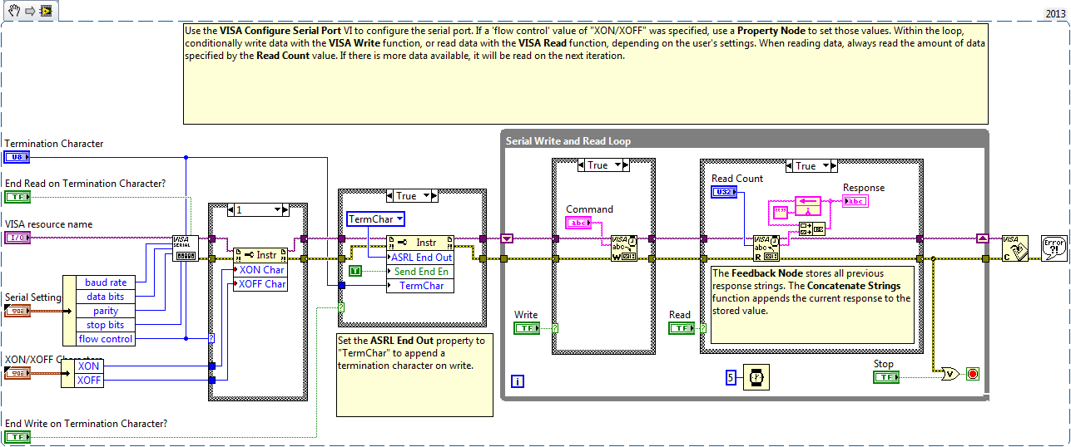

Figure . LabVIEW Continuous Serial Read and Write Example

In the first few prototypes the amount of bytes to be read were unclear thus a Property Node was used to detect the Serial Settings of that COM port, as seen in Figure 24 enclosed in the red box.

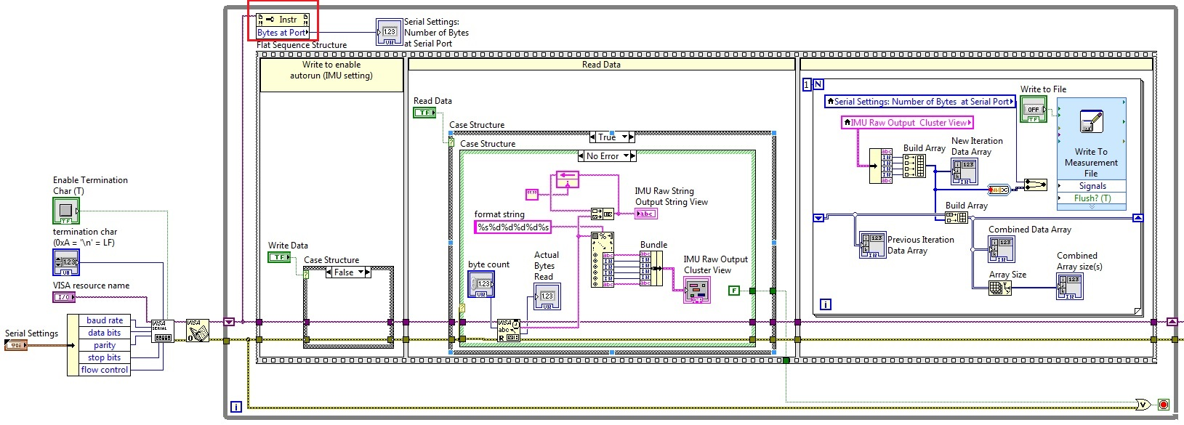

Figure . LabVIEW VI Early Prototype before Producer/Consumer Method

Another issue arose as to how to sample a gait pattern, after several observations of each specific the movement it was deduced that the amount of data to collect is dependent upon how quick the movement is performed i.e. the gait, as each individual has a unique body. It is predicted that the running gait pattern will have less samples, due to the action being performed quicker than walking. The baseline will be assumed a stationary position that mimics both standing and sitting.

## Data Preparation

As previously mentioned in section 12.2, various prototypes were developed the few were aimed at determining the manipulation of data read from the device. Using the textbooks provided by UTS to learn more about string manipulation, the Scan From String function was among one of the many tested string methods that succeeded, Figure 37 depicts the other two string manipulation methods that did not operate as intended. The Scan From String function was simple and easy to use thus was chosen out of the other methods.

The preparation phase with reference to Figure 24, involved the data collected being wired directly to the Scan From String function which converts the input string to the formatted output. The format string used to convert the string input required knowledge of the IMU output format, as indicated in Figure 13, Figure 16 and on the data sheet (refer to Appendix B – 6 Degrees Of Freedom v4 Datasheet). The readings begin with the character A and ends with Z, the numbers inside of this denote the sample count, X, Y and Z-axis accelerometer readings in that order. The operator % followed by either one of the two conversion codes d or s, decimal and string respectively, allows the single string to be separated into individual outputs.

A revision later, queues were introduced to tackle an error that caused the IMU stop its Auto run mode and display the sampling error “*Too much data. Please lower your sample frequency*”. As the IMU was running at its lowest frequency of 10Hz, this fault was due to the computer, since it was not running optimally as the data is not being processed fast enough. This error also resulted in the data format of the Scan from String function to be incorrect and thus an error code “*LabVIEW: Scan failed. The input string does not contain data in the expected format.*” where the expected string was “*A 0 123 123 123 Z*”. The sampling error above was displayed instead of the expected string thus leading to this Scan From String error.

The introduction of queues minimized the data pileup error from occurring however, it was deduced that the transmission of data was too slow as the problem kept occurring. This particular error had affected the projects progress greatly, as a last resort the problem was overcome by ignoring the error and re-enabling the Auto-run mode on the IMU achieved using Case Structures. Troubleshooting with LabVIEW led to no new results therefore a different approach was taken, troubleshooting via NI MAX led to the discovery that 18 bytes represented the first few outputs of the IMU. Below is a sample of data read from the IMU via NI MAX:

“*1: Read Operation, Return Count: 18 bytes: A\t3\t513\t500\t774\tZ\n*”

where each ASCII letter represented a byte and similarly with the delimiters “*\t*” and “*\n*” all sum up to 18 bytes. Thus, it was deduced that the maximum number of bytes to be read would be 24 bytes, this byte calculation accounts for four digit readings from the sample and accelerometer readings should the IMU be required to sample for that lengthy duration.

The Queue function is provided in the base development system of LabVIEW and can be found in the Queue Operations Functions, it is typically utilized to allow data availability to other functions whilst maintaining the programs synchronicity.

The purpose of producing queues is to isolate the reading and manipulation of data, this idea is modeled upon the Producer/Consumer Design Pattern template provided by the LabVIEW software.

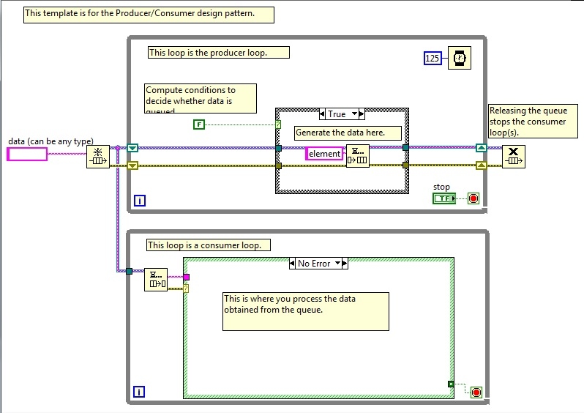

Figure . LabVIEW Producer/Consumer Data Pattern Template

The consumer loop seen in Figure 25 is where the data collected in the producer loop is extracted from the queue using a Dequeue Element function.

A Case Structure was introduced to the inside of the Data Collection Phase loop and a logical numerical comparison was used to determine whether the data is to be processed into queue (refer to Figure 27) or Auto-run mode is to be enabled (refer to Figure 28). The logic numerical comparison was based upon the discovery of the number of bytes read from a typical sample string output. This solution fixed the sampling error however the Scan From String error did not have any logical means of being fixed should the event occur, thus it was wired that the error to be reset all the time as seen in Figure 29.

## Data Preprocessing

The final processing step prior to the gait analysis achieved by means of K Means clustering. The converted data is taken from the queue and built into arrays, where the individual accelerometer readings of the X, Y Z axis are paired up with the sample count. This final array is fed into the inner For loop where the algorithm performs its analysis.

An additional preprocess was incorporated to compensate for the varying Z-axis, this is due to gravity affecting readings on the Z-axis. This offset is introduced, as the test data was attained at specific height, therefore should the testing environment change the new Z-axis readings would be incorrect thus leading to skewed results. The X and Y-axis readings remain the same as the IMU is placed in such a way that the magnitudes of the readings are dependent upon the swinging motion produced by the test subject’s limb.

Due to the errors in the previous stages of data collection and preparation, it was thought that the sample counts might be inconsistent thus the sample count readings were ignored and the While loop iterations were used as the sample count instead. This is possible as every iteration a single reading is processed thus one sample count.

## Algorithm Implementation

An unsupervised learning algorithm was chosen to classify the training set of IMU accelerometer axis readings into K number of clusters. The K Means clustering algorithm is implemented due to its wide applications in other research areas (*reference of study application for K Means*), its simplicity and in particular its memory usage and training time in comparison to KNN, the other unsupervised learning algorithm.

Similar to how the serial read and write example was found in section 12.2, a typical K means clustering example was discovered and analyzed to suit the needs of this project (refer to section 2.1.1 of

Appendix D – Machine Learning Toolkit User Manual).

## Algorithm Training Parameters

The analysis of the K Means clustering example (refer to section 2.1.1 of

Appendix D – Machine Learning Toolkit User Manual) to the discovery that the training parameters of the K means clustering is simple, the user is required to enter a K number of classes/clusters to be displayed on the graph. The k number of class/cluster indicators for each axis were not wired but rather were referenced by Local Variables found in the Structures category, essentially this allowed the same indicator to alter all three gait parameters simultaneously, it reduces the overall wiring and clutter on both the VI Front Panel and Block Diagram. This method was repeated for the internal For loop where the training and testing of the model occurred and the distribution of the preprocessed data to each individual pattern i.e. each of the three For loops.

## Train and Testing of Model

The two Sub VI’s mentioned in section 11.1.1.7 were developed alongside the implementation of this system, they were originally apart of the main system however have been compartmentalized to reduce space and clutter in the programs block diagram. This was made possible as these particular functions were to be repeated for each time a pattern had to be read from file. The idea of compartmentalizing came from the observation of the internal operations of the MLT VI’s and including the various prebuilt LabVIEW functions.

The process of data being extracted from external files and built into arrays produced different orientations to when they were written to file from the program. This orientation was not the correct format and was easily remedied; the solution was to transpose the built array essentially flipping the orientation of the data.

## Model Evaluation

The initial evaluation between the test and trained data sets were not computed, the simple explanation was that the arrays of both sets of data varied, thus the development of a separate VI with the sole purpose of producing a fixed array size began. This separate array was to input the new readings into the last element of the array whilst deleting the first element of the array to ensure the size remained the same. The application of this array to the main VI allowed the evaluation techniques to work, however the downside is that the display was limited to the amount of samples of each trained pattern.

The testing of evaluation techniques was conducted with the purpose of determining the reliability of the assessments of these techniques. The testing conditions involved running several iterations of a single pattern such as walking or running, this particular set is evaluated against itself such that the output of all the methods would return a result indicating they are a 100% match.

The results concluded that the Rand Index was a more reliable method at classifying the patterns and required less data manipulation as the functions output was of a double datatype with values ranging from ‘0.0’ to ‘1.00’, where ‘0.0’ is no match and ‘1.00’ being a 100% match between the two patterns.

The evaluation model only requires two inputs into the function, the trained model and the baseline model. The program has allowed a minimum % match to account for noise, different human anatomies and physiologies which affect the gait patterns, as each individual will have unique gait due to several factors such as their age, height, weight and injuries. The minimum % match varies greatly between walking and running as running is a faster and more dynamic movement than passive walking.

After the above was completed a solution to allowing the user to control the samples began, the testing occurred in a duplicate VI to ensure all functionality remained the same in case of any irreversible changes. After several prototypes of array manipulation, it was deduced that introducing a timer to slow down the computation of the algorithm was the only possible method for a user to see each sample iteration individually.

# Conclusion

The program revolving around the K Means clustering algorithm was completed within the time restrains of the project and in working order however, the programming required to reach the algorithm phase was quite intensive.

In conclusion, the final LabVIEW VI design for gait patterning is still incomplete in many aspects, one such example is its database. The pattern evaluation of the program is limited to the most common performed movements i.e. walking and running.

The accuracy of the Rand Index evaluations on the trained data sets fluctuated, this is most likely due to the data, which is read from file and wired into the K Means algorithm to be re-trained.

Despite the incomplete gait pattern database, the program successfully analyses the gait patterns and provides an appropriate evaluation.

## Future Works

The LabVIEW VI was developed for its simplicity in analyzing the main forms of gait, which were mentioned earlier to be the walking and running. There are certain restrictions in the above VI such as the evaluation of each pattern to be of the same number of samples, thus this limitation can be improved upon by increasing the samples for both the test and trained patterns. For the scenario when the test samples exceed the trained patterns sample size of 50 e.g. 60 samples from the test and trained, here the trained data should copy itself however it would only add first 10 samples of the trained pattern to the end of itself. This method removes the restricted evaluation window thus providing a wider perspective of the analysis. This is possible as the sampled gait patterns are equivalent to one complete cycle of walking and running, thus the addition of the first 10 samples to the end of the 50 samples would essentially create a pattern of continuous walking.

The data of the trained patterns should consist of the labels that the algorithm output rather than the IMU readings.

# References

[1] Benocci, M., Rocchi, L., Farella, E., Chiari, L. & Benini, L. 2009, 'A wireless system for gait and posture analysis based on pressure insoles and Inertial Measurement Units', Pervasive Computing Technologies for Healthcare, 2009. PervasiveHealth 2009. 3rd International Conference on, IEEE, pp. 1-6.

[2] Tao, W., Liu, T., Zheng, R. & Feng, H. 2012, 'Gait analysis using wearable sensors', Sensors, vol. 12, no. 2, pp. 2255-83.

[3] Salarian, A.; Russmann, H.; Vingerhoets, F.J.; Dehollain, C.; Blanc, Y.; Burkhard, P.R.; Aminian, K. Gait assessment in Parkinson’s disease: Toward an ambulatory system for long-term monitoring. IEEE Trans. Biomed. Eng. 2004, 51, 1434–1443.

[4] Saremi, K.; Marehbian, J.; Yan, X.; Regnaux, J.; Elashoff, R.; Bussel, B.; Dobkin, B.H. Reliability and validity of bilateral thigh and foot accelerometry measures of walking in healthy and hemiparetic subjects. Neurorehabil. Neural Repair 2006, 20, 297–305.

[5] Atallah, L.; Jones, G.G.; Ali, R.; Leong, J.J.H.; Lo, B.; Yang, G.Z. Observing recovery from knee-replacement surgery by using wearable sensors. In Proceedings of the 2011 International Conference on Body Sensor Networks, Dallas, TX, USA, 23–25 May 2011; pp. 29–34.

[6] Aminian, K.; Najafi, B. Capturing human motion using body-fixed sensors: Outdoor measurement and clinical applications. Comput. Animat. Virtual Worlds 2004, 15, 79–94.

[7] J. Ma ̈ntyja ̈rvi, M. Lindholm, E. Vildjiounaite, S.-M. Ma ̈kela ̈, and H. J. Ailisto, “Identifying users of portable devices from gait pattern with accelerometers,” in IEEE International Conference on Acoustics, Speech, and Signal Processing, March 2005.

[8] Gafurov, D., Helkala, K. & Søndrol, T. 2006, 'Biometric gait authentication using accelerometer sensor', Journal of computers, vol. 1, no. 7, pp. 51-9.

[9] D. Gafurov, E. Snekkenes, and T. E. Buvarp, “Robustness of biometric gait authentication against impersonation attack,” in First International Workshop on Information Security (IS’06), OnTheMove Federated Conferences (OTM’06), Montpellier, France, Oct 30 - Nov 1, 2006, Springer LNCS, to appear.

[10] A. Sant'Anna and N. Wickström, "DEveloping a Motion Language: Gait Analysis from Accelerometer Sensor Systems," 3rd International Conference on Pervasive Computing Technologies for Healthcare, London, 1-3 April, 2009, p. 1-8.

[11] Yang, M., Zheng, H., Wang, H., McClean, S. & Newell, D. 2012, 'iGAIT: An interactive accelerometer based gait analysis system', Computer Methods and Programs in Biomedicine, vol. 108, no. 2, pp. 715-23.

[12] Nowlan, M.F. 2009, 'Human recognition via gait identification using accelerometer gyro forces', Available: cs-www. cs. yale. edu/homes/mfn3/proj/mfn_gait_id. pdf.

[13] Sprager, S. & Zazula, D. 2009, 'Gait identification using cumulants of accelerometer data', 2nd WSEAS International Conference on Sensors, and Signals and Visualization, Imaging and Simulation and Materials Science, pp. 94-9.

[14] Kennedy, R.L. 1997, Solving Data Mining Problems Through Pattern Recognition, Prentice Hall PTR.

[15] Vathy-Fogarassy, Á. & Abonyi, J. 2013, Graph-Based Clustering and Data Visualization Algorithms, Springer.

[16] Maulik, U. & Bandyopadhyay, S. 2002, 'Performance evaluation of some clustering algorithms and validity indices', Pattern Analysis and Machine Intelligence, IEEE Transactions on, vol. 24, no. 12, pp. 1650-4.

* Learning Algorithms: Theory and Applications in Signal Processing, Control and Communications

Costs

<http://entertainmentengineeringanddesign.pbworks.com/w/page/19116690/Sensors>

<http://www.canakit.com/imu-6dof-v4-sensor-board-sen-08726.html>

<http://www.ponoko.com/make-and-sell/show-hardware/726-a-imu-6dof-v4-sensor-board?source_node=ponoko_united_states>

<http://www.amazon.com/IMU-6DOF-v4-Sensor-Board/dp/B004G2DFDM>

# Appendices

Appendix A – LabVIEW Virtual Instrument

Appendix B – 6 Degrees Of Freedom v4 Datasheet

Appendix C – Three Axis Low-g Micro machined Accelerometer (1.5 – 6g) Datasheet

Appendix D – Machine Learning Toolkit User Manual

## Appendix A – LabVIEW Virtual Instrument

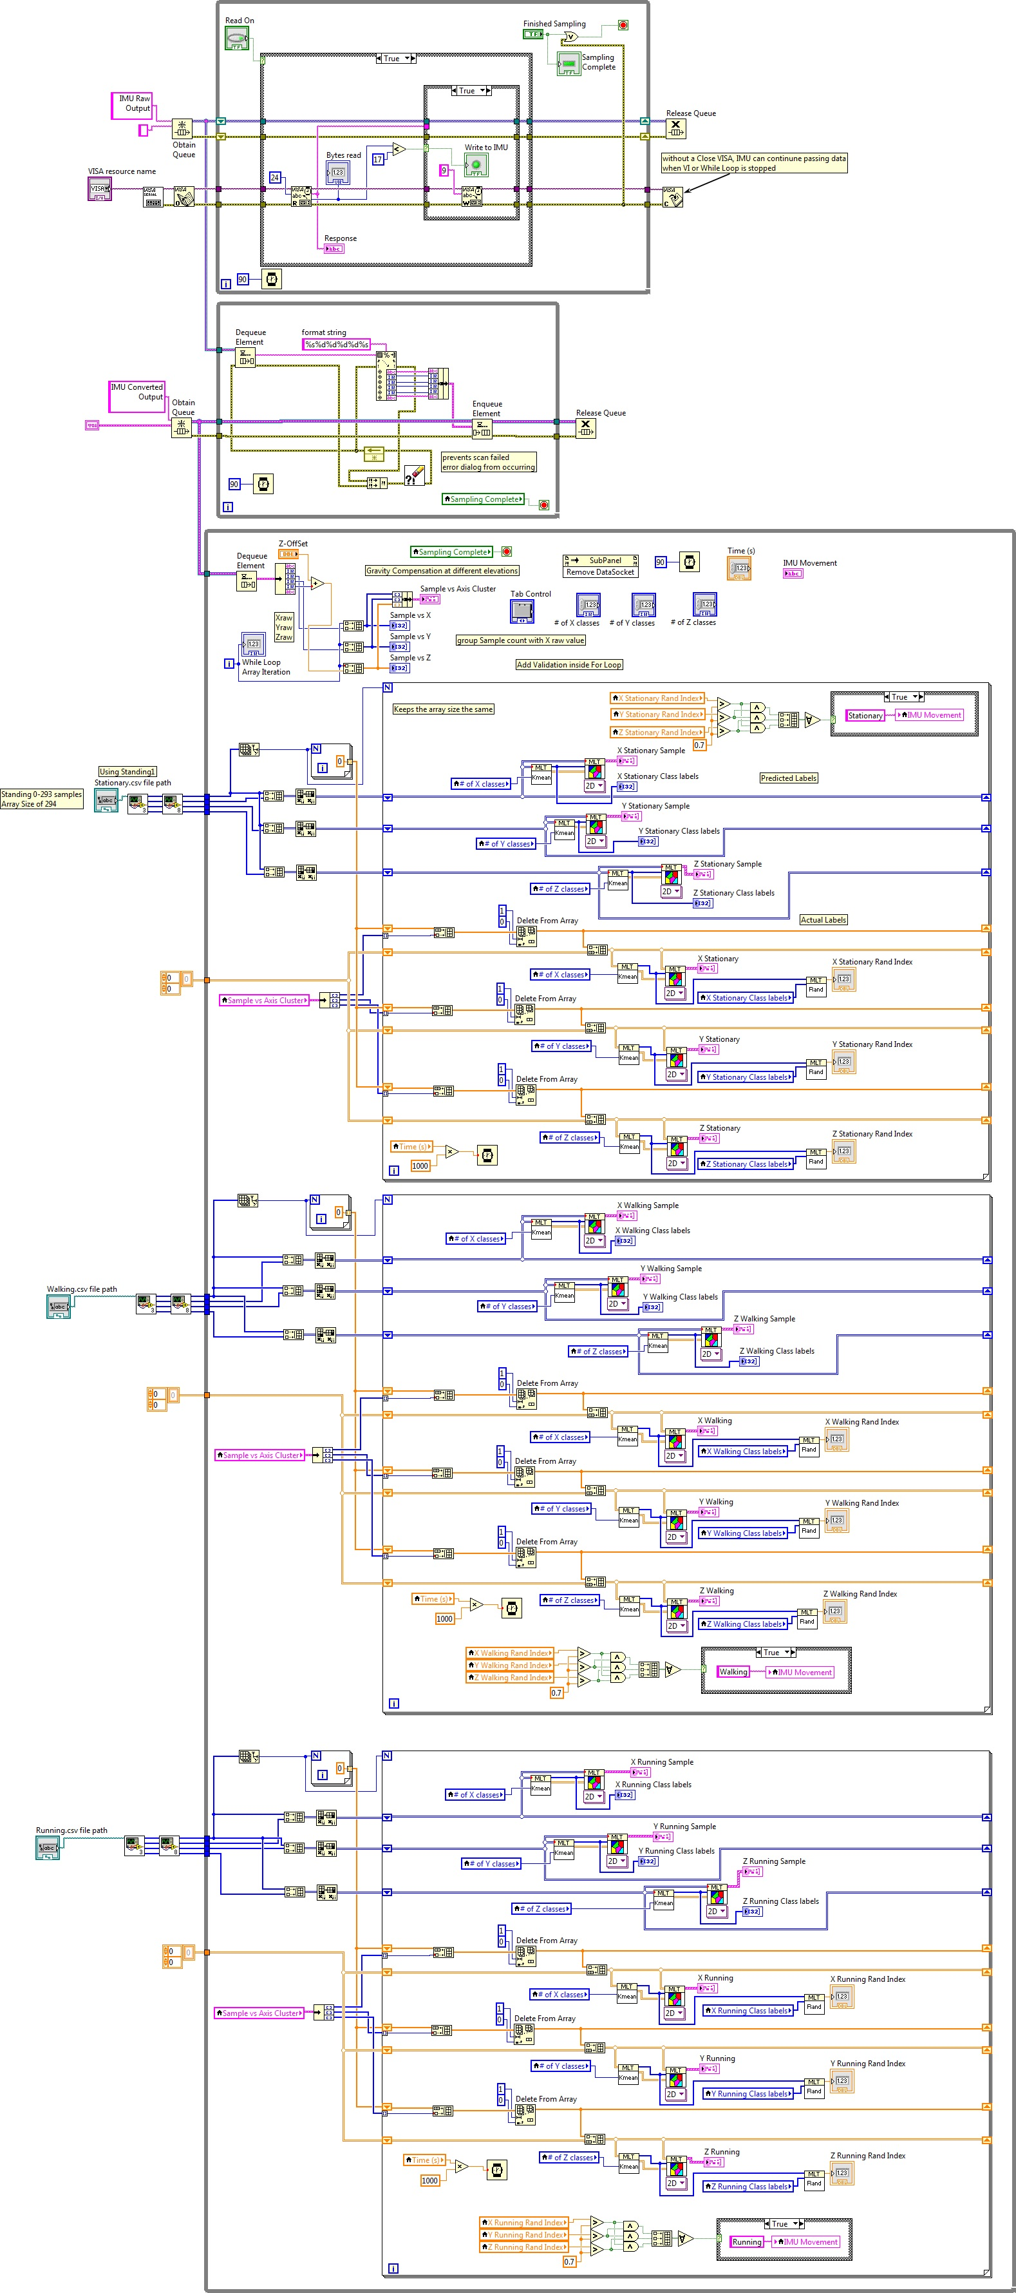

Figure . LabVIEW Complete Program Overview

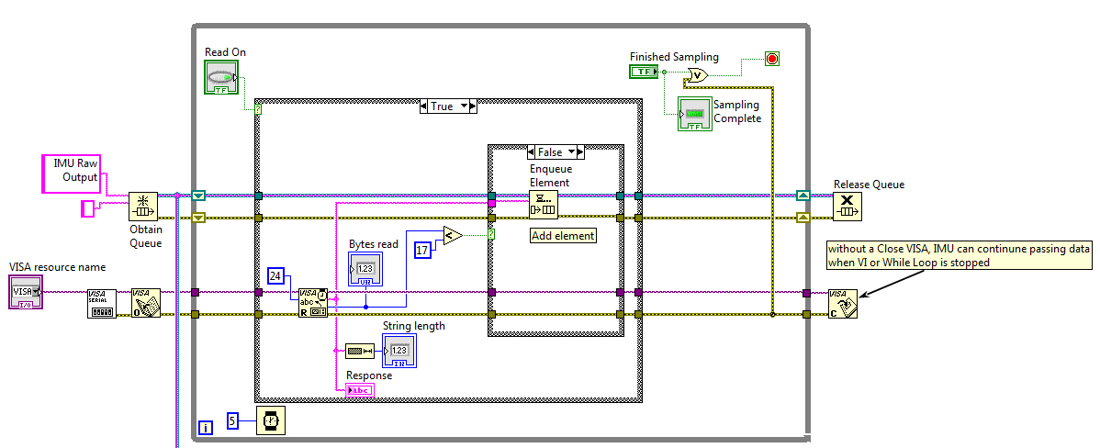

Figure . LabVIEW Data Collection Phase False Case

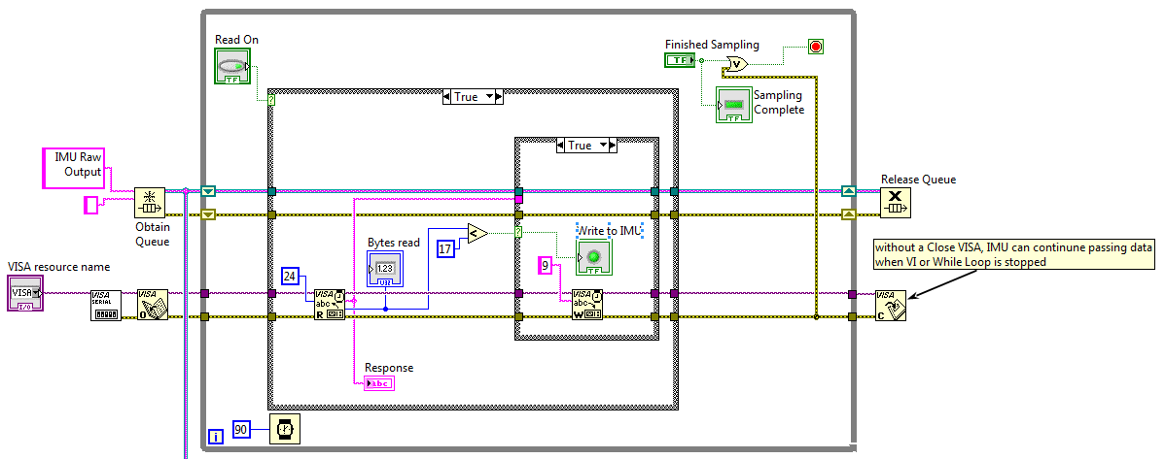

Figure . LabVIEW Data Collection Phase True Case

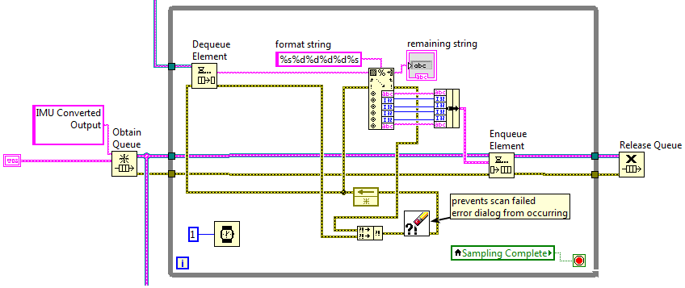

Figure . Data Preparation Phase

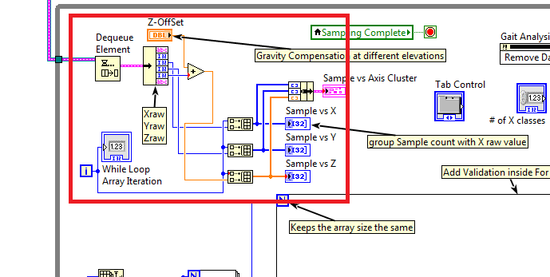

Figure . Data Preprocessing Phase

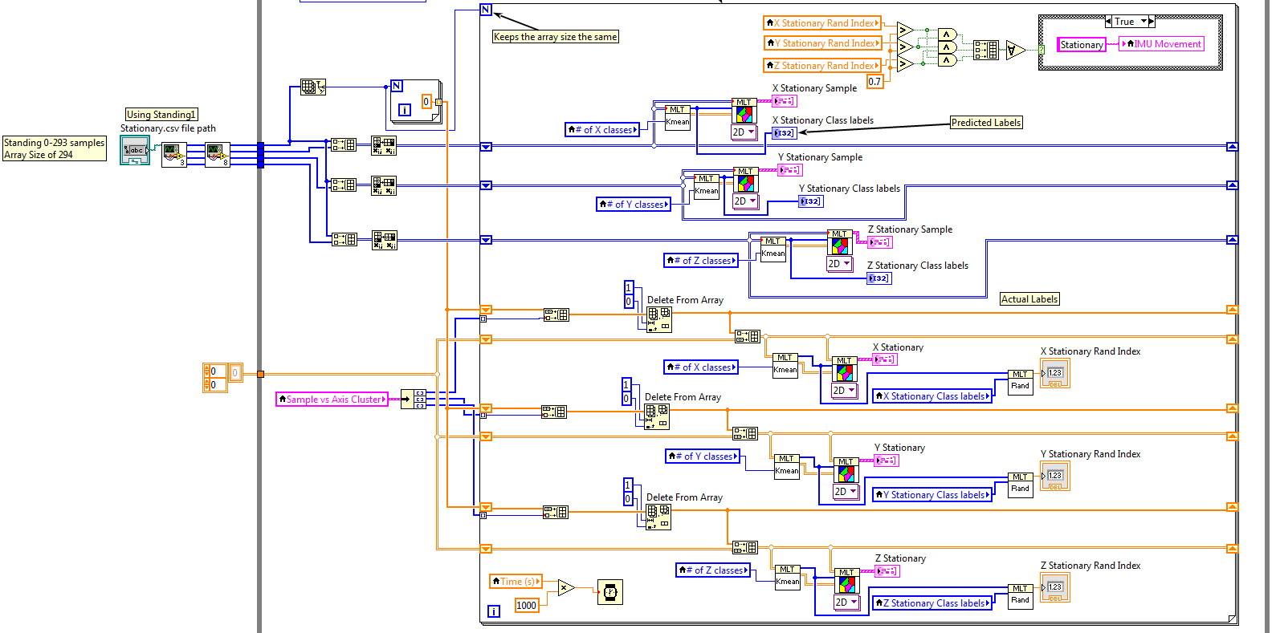

Figure . Algorithm Implementation, Training, Testing & Evaluation (1/3) – Stationary

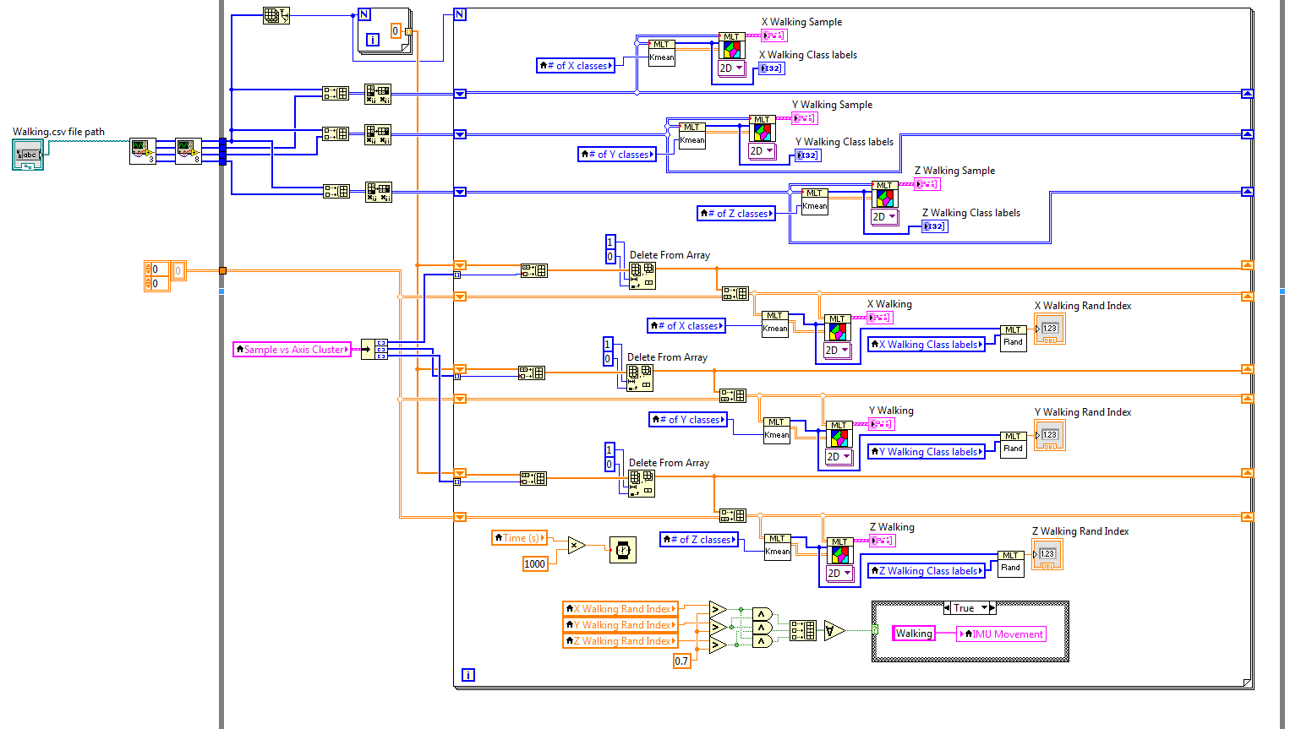

Figure . Algorithm Implementation, Training, Testing & Evaluation (2/3) – Walking

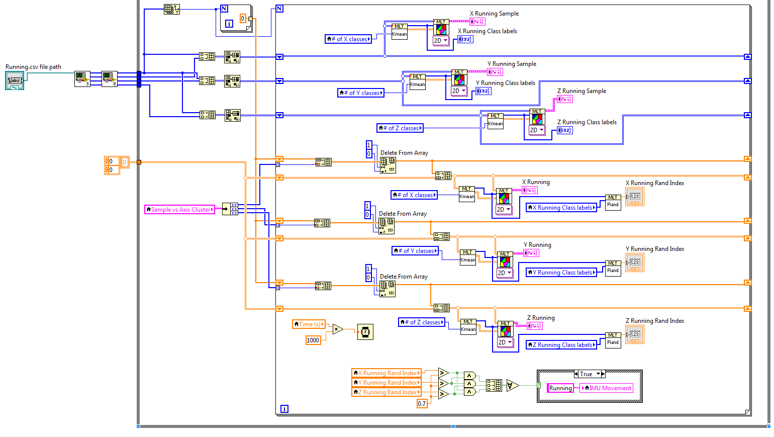

Figure . Algorithm Implementation, Training, Testing & Evaluation (3/3) – Running

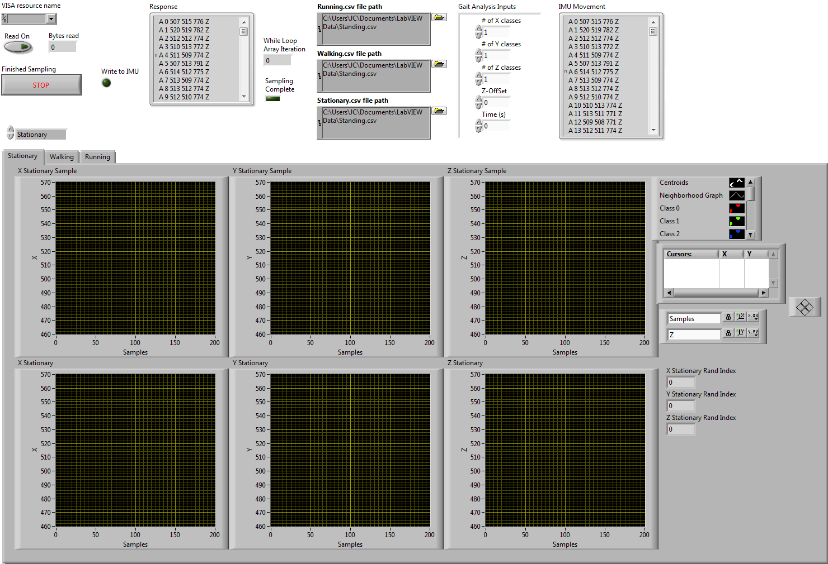

Figure . LabVIEW VI Front Panel

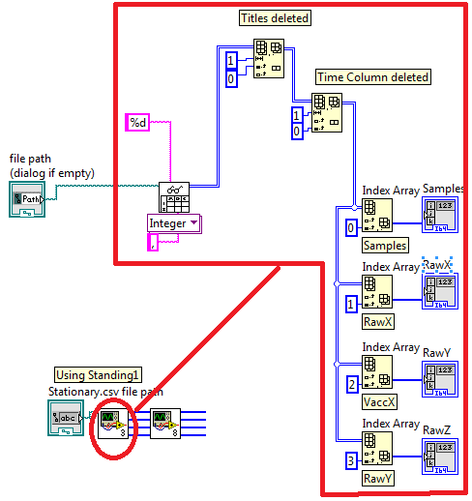

Figure . Read From CSV File Sub VI

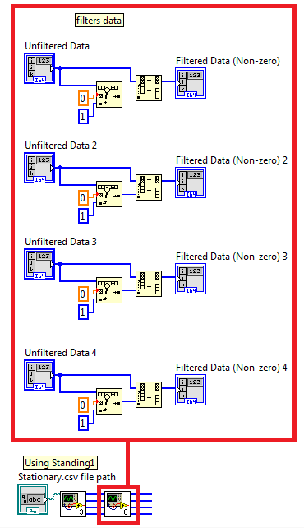

Figure . Filter File Non-zero Data Sub VI

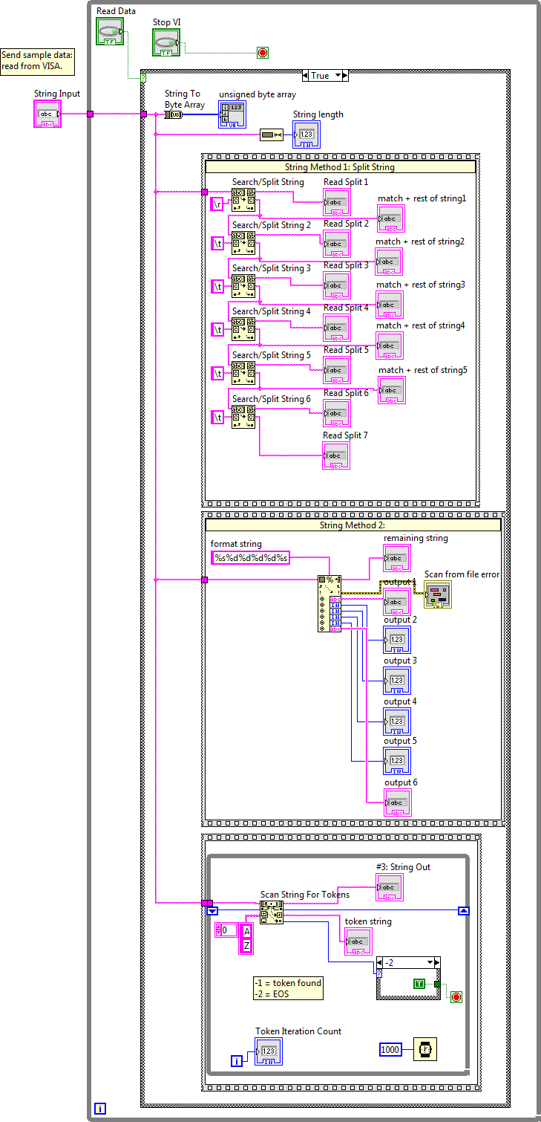

Figure . String Manipulation Prototype

## Appendix B – 6 Degrees Of Freedom v4 Datasheet

## Appendix C – Three Axis Low-g Micro machined Accelerometer (1.5 – 6g) Datasheet

## Appendix D – Machine Learning Toolkit User Manual